**Step 1: Create an official register report on SIMS**

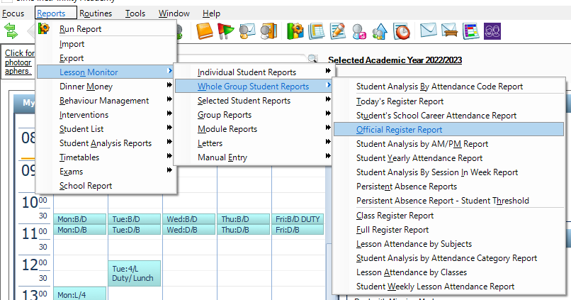

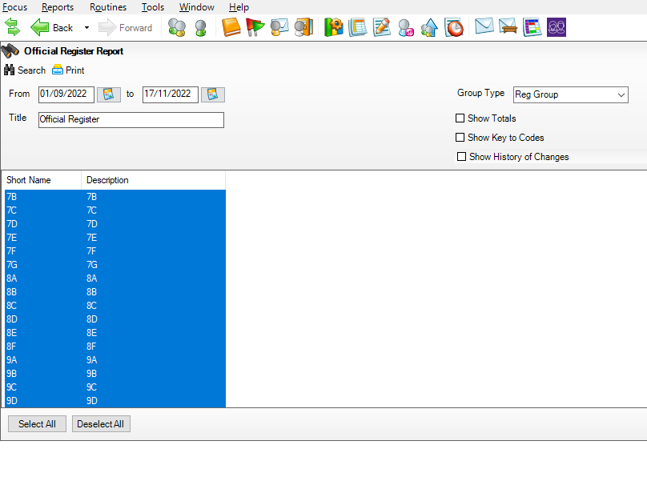**Step 2: Select all tutor groups and time window you want to analyse. Make sure that Group Type is ‘Reg Group’ and all three boxes are unticked.**

**Step 3: Use predefined report layout outputted to a web browser. This will create the official register organised by tutor groups.**

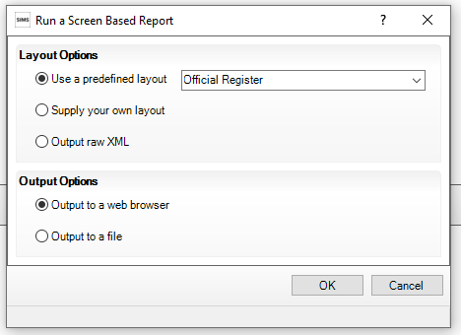

**Step 4: Press Ctrl – A to select all data in the register**

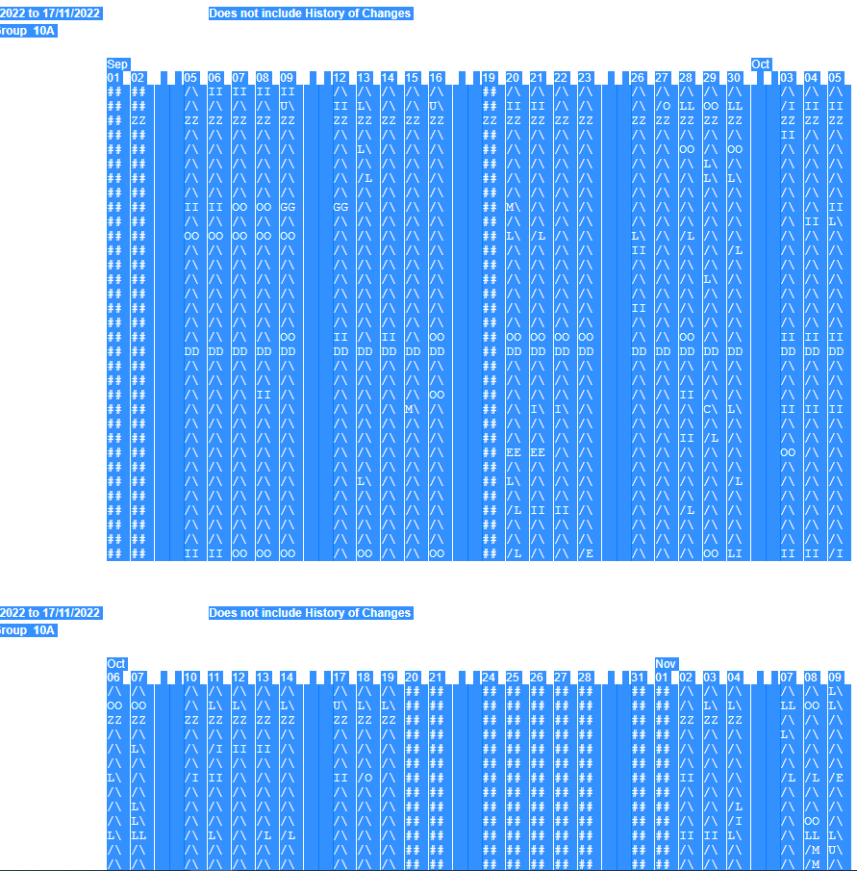

**Step 5: Copy and paste the register into an excel file by pasting into cell A1.**

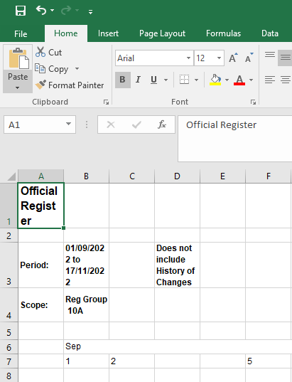

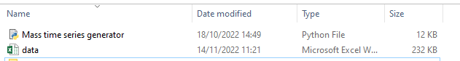**Step 6: Save the excel file under the name ‘data’ in the same directory as the Python script.**

**Step 7: The script produces non-cumulative weekly percentage attendance time series plots for each student and saves them in separate folders organised by tutor group.**

